Name : Israa Ragab Okil

Section : 2

20/2/2020

Quiz 1

1-

In the Hypothetical Machine the contents of memory was as shown. And PC contents is 300. Show the contents of memory and PC , AC , IR after execute three instructions (three fetch cycle and there execute cycle)

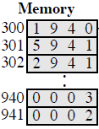

Answer :

Load

 PC : 300

AC : 0003

IR : 1940

Add

 PC : 301

AC : 0005

IR :5941

Store

 PC : 302

AC : 0000

IR : 2941

2-

* Show the contents of PC , AC and IR and memory after the execution of each instruction of the following program on the Hypothetical Machine:
* 300 LOAD 550
* 301 ADD 551
* 302 STORE 600
* Where the contents of memory at 550 is 3 and at 551 is 4.

Answer :

Load

300 : 1550 PC : 300

301 : 5551 AC : 0003

302 : 2600 IR : 1550

550 : 0003

551 : 0004

600 : 0000

Add

300 : 1550 PC : 301

301 : 5551 AC : 0007

302 : 2600 IR : 5551

550 : 0003

551 : 0004

600 : 0000

Store

300 : 1550 PC : 302

301 : 5551 AC : 0000

302 : 2600 IR : 2600

550 : 0003

551 : 0004

600 : 0007

* 3-
* The following figure provide the main characteristics of Hypothetical Machine.
* 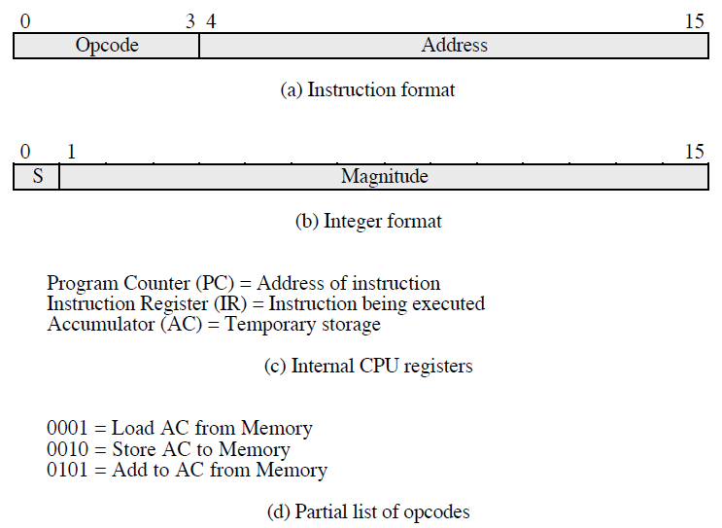

The hypothetical machine also has two I/O instructions:

0011 = load AC from I/O

0111 =store AC to I/O

In these case, the 12-bi address identifies a particular I/O device. Show the program execution for the following program:

1. Load AC from device 5.

2. Add contents of memory location 940.

3. Store AC to device 6.

Assume that the next value retrieved from device 5 is 3 and that location 940 contains a value of 2.

Answer :

300 : 3005

301 : 5940

302 : 7006

Device 5 : 0003

940 : 2

Device 6 : 0005